Resource List of Practitioners & Services for Women
A curated directory of female‑focused practitioners, coaches, and service providers.

Ali Crocker
Specialist Pelvic Health Physiotherapist 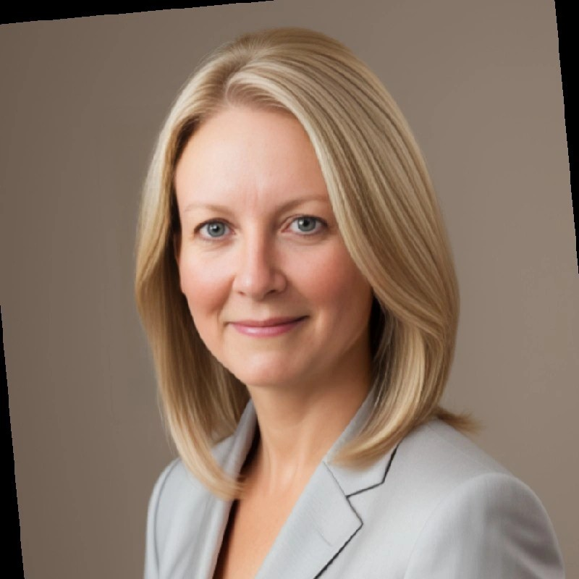
20 years’ NHS & private experience; MSc in Continence & Uro‑Gynaecology; treats incontinence, prolapse, pelvic pain and more.

- Contacts:
Email: ali.crocker@nuffieldhealth.com

Amanda D.
Trauma-Informed Holistic Wellbeing Practitioner, Founder of Liminal Connections
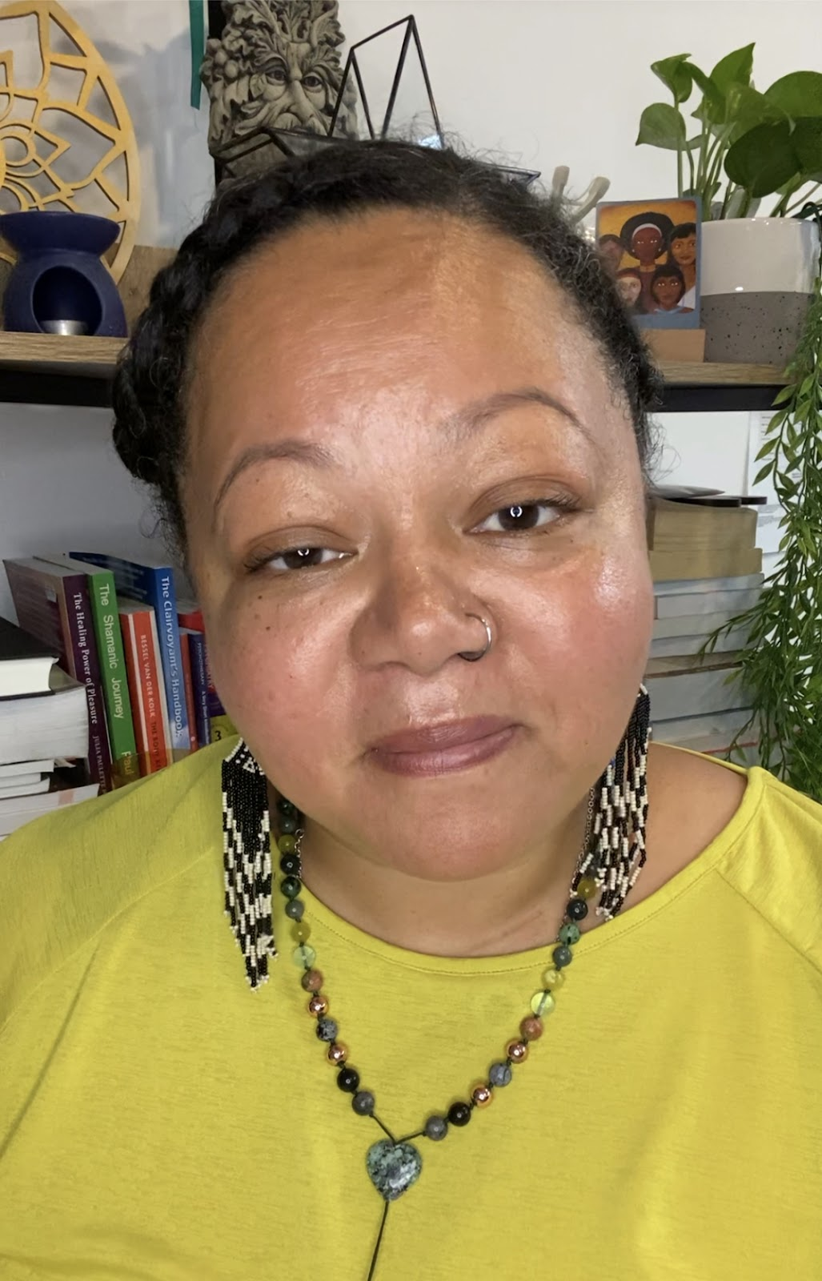
A trauma-informed and highly experienced Holistic Wellbeing Practitioner, by her own lived experiences and those as a registered mental health nurse.

- Contacts:
Mobile/WhatsApp: 07848 197833
Email: hello@liminalconnections.co.uk
Website: www.liminalconnetions.co.uk
Facebook: https://www.facebook.com/liminalconnections/
Instagram: https://www.instagram.com/liminalconnectionsuk/
LinkedIn: www.linkedin.com/in/LiminalAmandaD

Amber Silverman
Nutritional Therapist – Nutrition For Health
Supports clients with long‑term, judgment‑free nutrition programmes and a recipe app for simple, healthy meals.

- Contacts:
Email: amber@nutrition-for-health.org
Website: nutrition-for-health.org
Instagram: @amber.nutritionforhealth

Anna Glowacka (she/her)
Women’s Health Advocate, Founder – Moon Women’s Health
- Contacts:
Email: anna@mwhealth.co.uk
Website: www.mwhealth.co.uk
Instagram: instagram.com/moon_womens_health
Facebook: facebook.com/MoonThreeAgeWomensHealth
Massage therapist since 2009 and founder of Moon Women’s Health in North London. Anna supports girls and women across the life‑cycle, inspired by her own birth experiences.

Chantal Naqvi
Psychotherapist
- Contacts:
Email: therapywithchantal@gmail.com
Website: therapywithchantal.com
Provides integrative therapy in a safe, inclusive space.

Christine B.
Founder – Magical Baby Moments (Hypnobirthing)
Offers antenatal hypnobirthing classes inspired by her own positive birth experiences.
- Contacts:
Email: hello@perfectlayout.co.uk
Website: magicalbabymoments.com

Chris Ward RN (MH)
Solution Focused Therapist & Coach 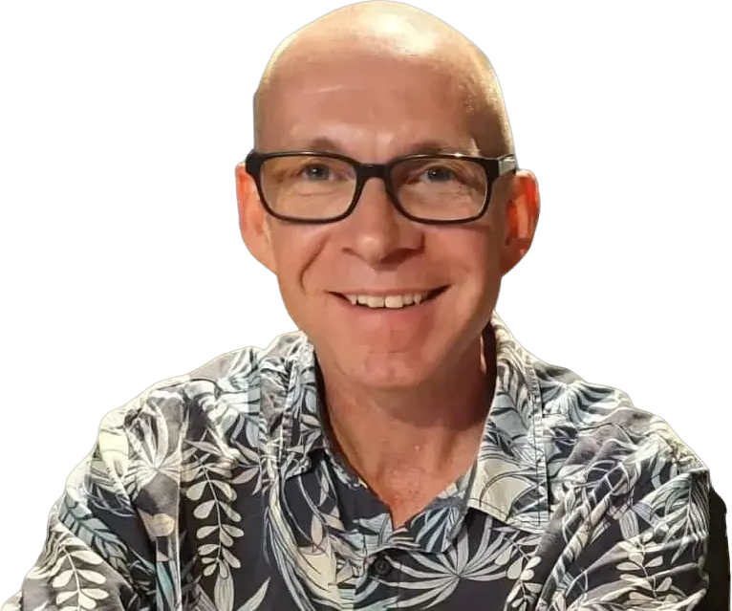
UKASFP‑accredited practitioner helping neurodivergent and creative clients find happiness and success through solution‑focused therapy.

- Contacts:
Email: hello@chrisward.life
Mobile: +44 7747 497 751
Instagram: @chrisward_sfs
YouTube: @chrisward_sfs
Facebook: Chris Ward Solution Focused Services
LinkedIn: Chris Ward
Website (more information and booking): https://chrisward.life/
Blog: https://keepcalmandsolutionfocused.com/
United Kingdom for Solution Focused Practice (UKASFP): https://ukasfp.site-ym.com/

Dr Claire Phipps MBBS (BSc) MRCGP
GP & BMS‑Accredited Menopause Specialist 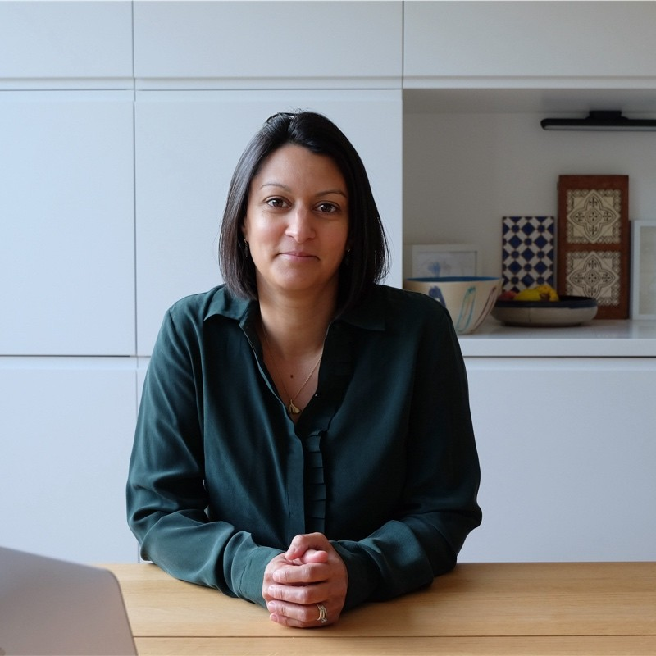
Provides holistic, individualised perimenopause and menopause care, specialising in complex cases.

- Contacts:
Email: cvphipps@googlemail.com
Website: themenopausesisters.com
Instagram: @themenopausegp

Daven Lee
Founder, “The Power of the Yin”
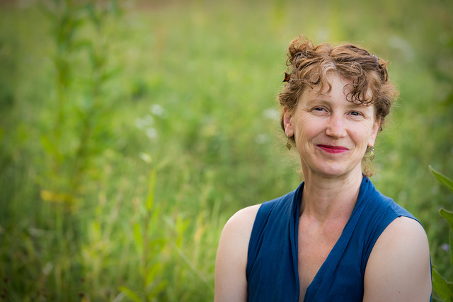
Yin-leadership guide, “gentle” sex & intimacy coach, and integrative craniosacral therapist. Creator of the Power of the Yin Oracle Deck, Daven leads 1-to-1 “Hello Sexual Soul” journeys and retreats that help women (and couples) reconnect to embodied feminine power and authentic sexuality.

- Contacts:
poweroftheyin@gmail.com
www.hellosexualsoul.com
www.yinoracle.com

Emily Hughes
Conscious Parenting Coach – Finding Flow Parenting 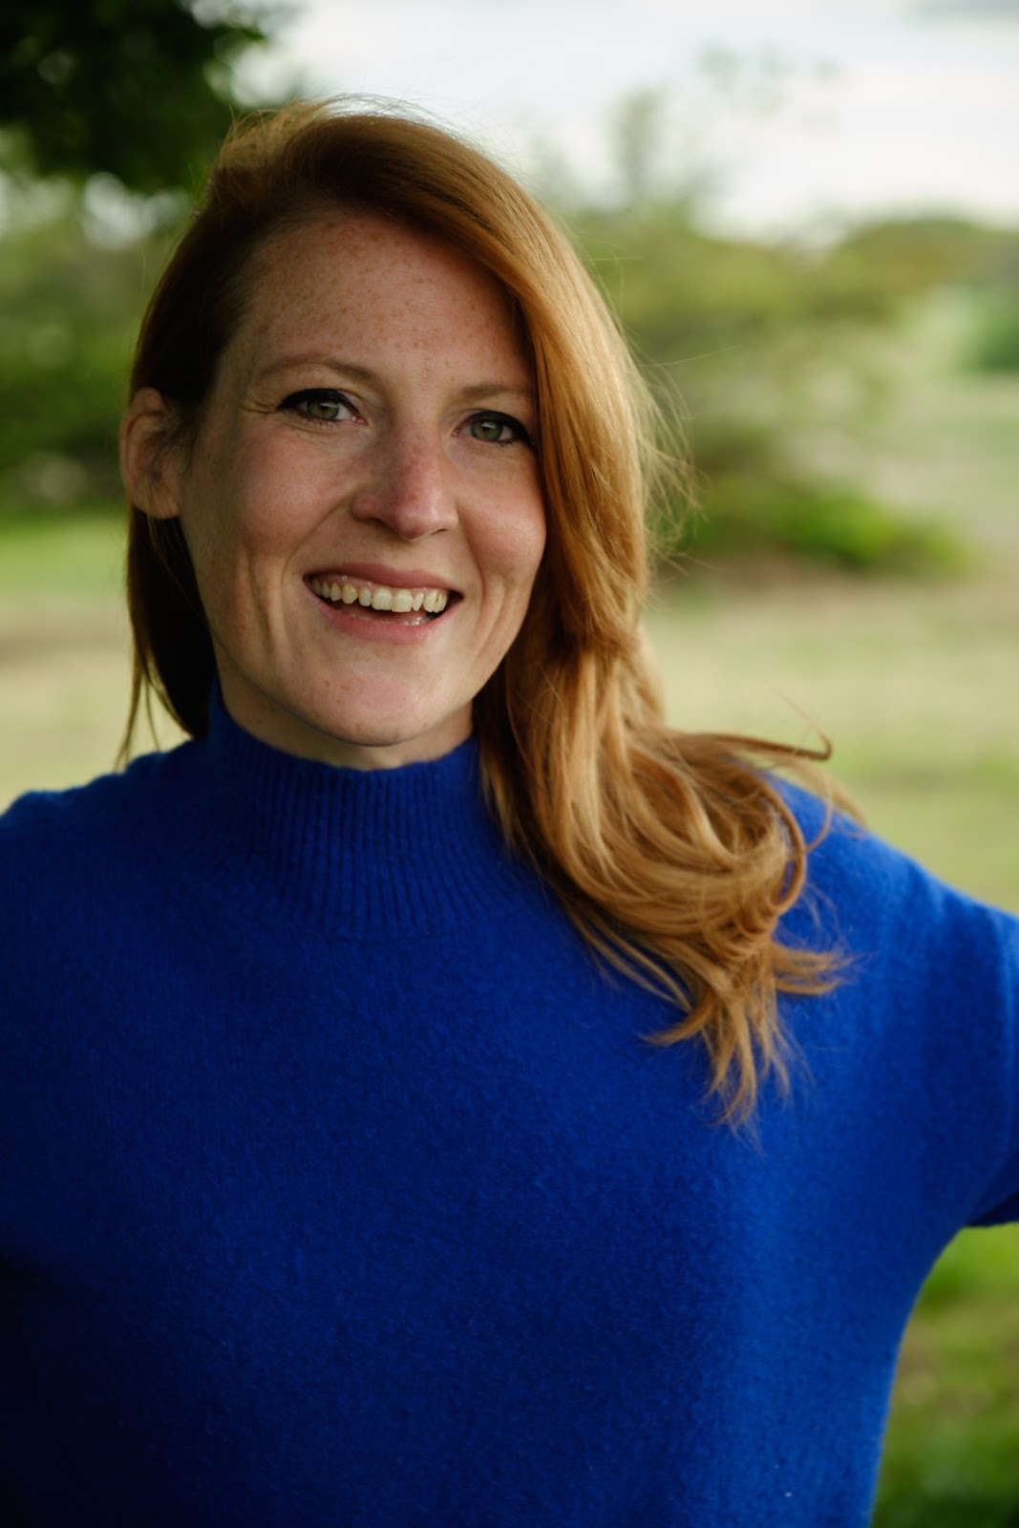
- Contacts:
Email: emily@findingflowparenting.coach
Website: www.findingflowparenting.coach
Instagram: @findingflowparenting
Facebook: www.facebook.com/findingflowparenting
Helps parents move from overwhelm to ease using somatic and emotional intelligence tools.

Francesca Lyon
Lead Nutritionist & Co-Founder, FUTURE WOMAN 
Francesca is a co-founder and the director of nutrition at FUTURE WOMAN, a women's health hormone testing company based in the UK. She specialises in women's health but in particular in fertility and ovulation disorders such PCOS and hypothalamic amenorrhea.

- Contacts:
Instagram: @futurewomanhq
Francesca's instagram: @your_hormone_naturopath
FUTURE WOMAN's Website: www.future-woman.com

Gabriella Weekes
Mindfulness Teacher, Author & Retreat Facilitator
Leads movement meditation and menstruation circles; author of ‘Quiet the Mind’ and founder of The Cave retreats.

- Contacts:
Email: info@gabriellaweekes.com
Website: www.gabriellaweekes.com
Instagram: @gabriellaweekes @retreattothecave
http://amzn.to/46xqrDP
https://insighttimer.com/spiritchild
https://www.mwhealth.co.uk/spirit-dance/
https://www.mwhealth.co.uk/moon-astrology--harnessing-the/

Jeanette Forder
Founder & CEO – Phoenix Wellness Coaching 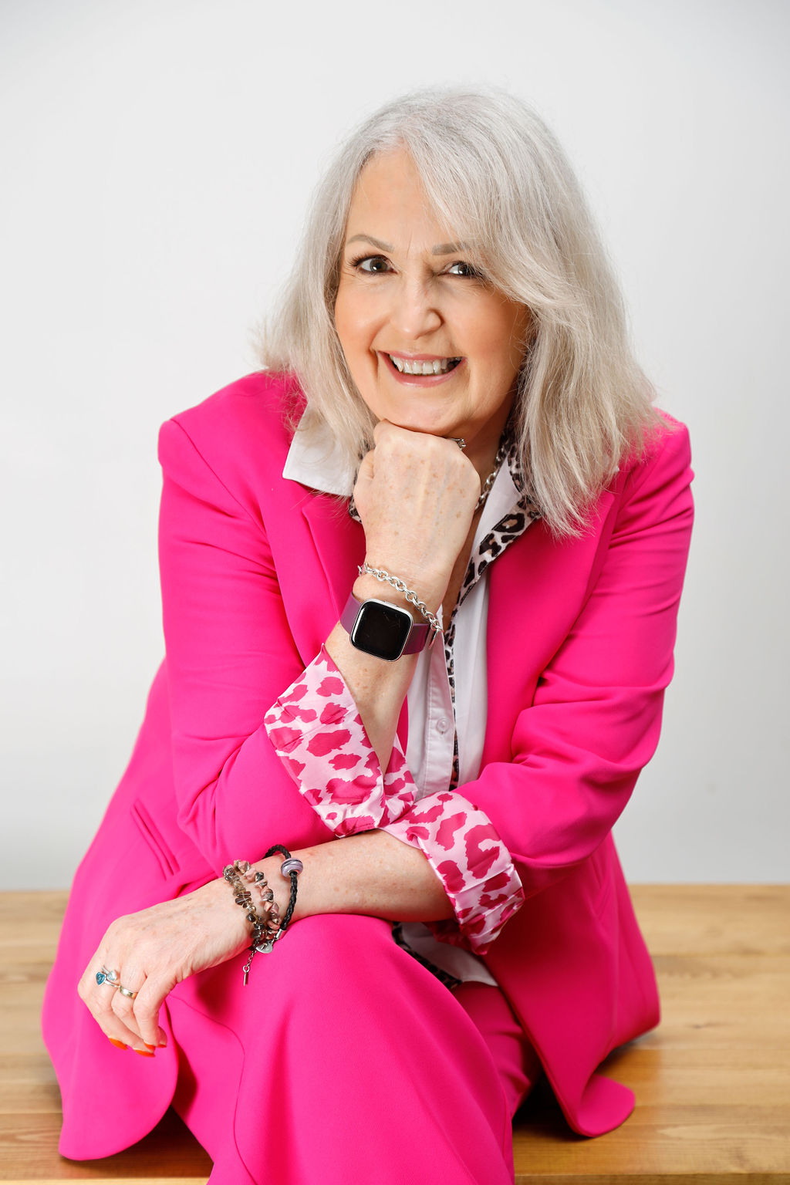
Wellness & life coach specialising in menopause support for individuals and organisations; Chartered CIPD & Senior ACCPH member.

- Contacts:
Email: jeanette@phoenixwellness.co.uk
Website: www.phoenixwellness.co.uk
Mobile: 07778 126 477
https://linktr.ee/phoenixwellness

Jess Kasriel
Registered Nutritional Therapist, Shamanic Healer, Reiki Practitioner & Yoga Instructor
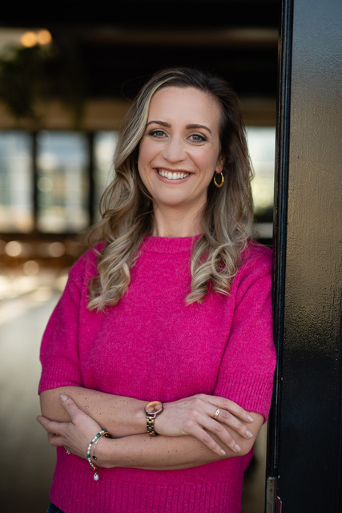
Registered Nutritional Therapist, shamanic healer, Reiki practitioner, and yoga teacher who helps women balance hormones, optimise fertility, and reconnect with their bodies through a unique mix of nutrition, movement, and energy work.
- Contacts:
jess@jesskasriel.com
www.jesskasriel.com
www.jesskasriel.com
@jess.kasriel

Kathryn Stagg IBCLC
International Board‑Certified Lactation Consultant
17+ years supporting breastfeeding families; author and founder of Breastfeeding Twins & Triplets UK; also a Holistic Sleep Coach.

- Contacts:
Email: kathryn@kathrynstaggibclc.com
Website: kathrynstaggibclc.com
Instagram: @kathrynstaggibclc

Lisa Watson RNC, ANP
Advanced Nurse Practitioner & Menopause Specialist – Watson Health
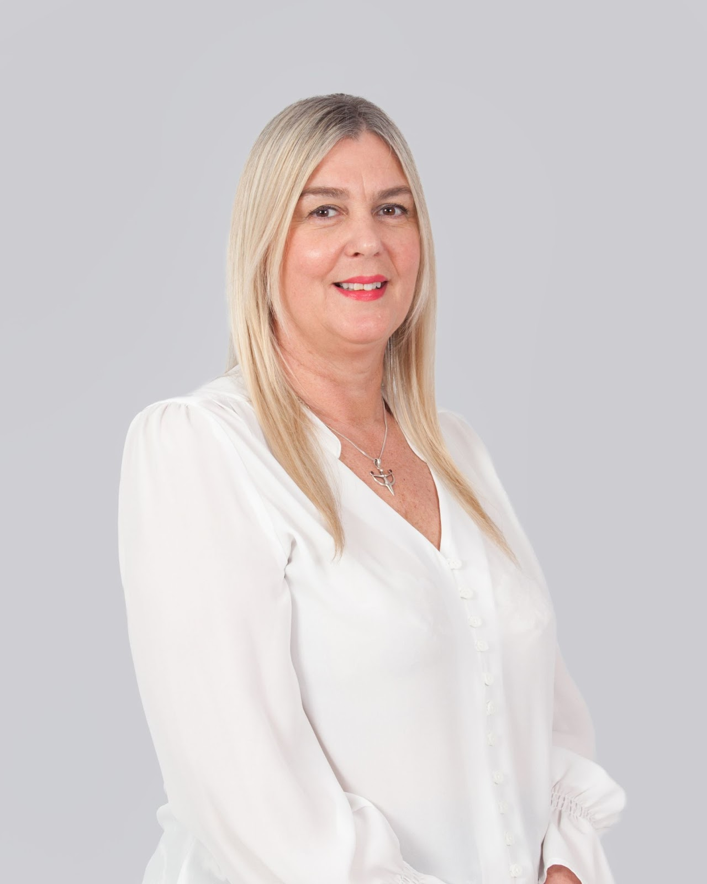
Registered nurse since 1989; delivers high‑quality menopause support in NHS and private settings.

- Contacts:
Email: lisa.watson@watsonhealth.co.uk
Website: www.watsonhealth.co.uk

Liana Fricker
Founder – Inspiration Space

Empowers solo founders and 'Companies of One' to grow with passion, profit and impact. Mentor for the Black Business Residency at Somerset House; named among Startups Magazine’s ‘Most Influential Women’ in 2022 and 2023.
- Contacts:
liana@theinspirationspace.co
www.theinspirationspace.co

Melanie Flood
Registered Nutritional Therapist & Health Coach
- Contacts:
Email: hello@melaniefloodnutrition.com
Website: melaniefloodnutrition.com
Mobile: 07714 471 423
Specialises in root‑cause nutrition, functional testing and 12‑week transformational programmes to restore energy and hormone balance.

Nada Soubra
Certified Metabolic Health Coach, Founder of The Healthy Chain 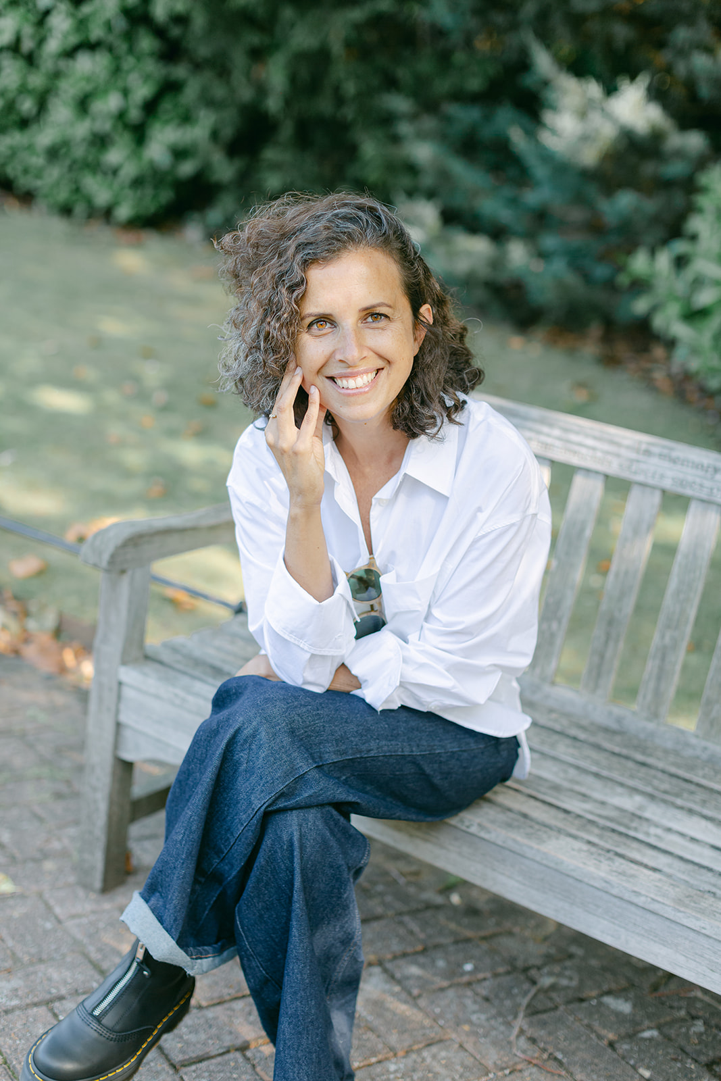
Nada helps busy people in early mid-life “thrive” by spotting the first signs of metabolic dysfunction and correcting them through personalised nutrition and lifestyle tweaks.

- Contacts:
Website: www.thehealthychain.co.uk
Instagram: @thehealthychain

Naomi Rogers
Creative Therapist – Red Thread Therapy
Offers holistic psychotherapy integrating arts and somatic work for women in North‑West London.

- Contacts:
Email: naomi.redthreadtherapy@gmail.com
Instagram: @red.thread.therapy

Natalie Lawrence
ICF-Accredited Life Coach & Hypnotherapist 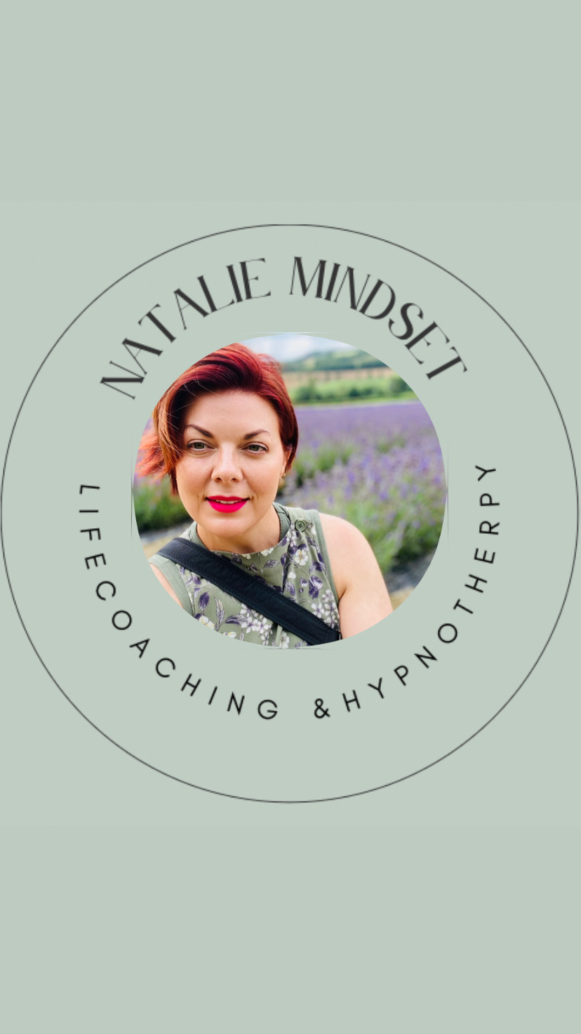
Host of the “Perfectly Imperfect Journeys” podcast, Natalie guides clients to move past anxiety and self-doubt and live more authentically through mindset coaching and hypnotherapy.

- Contacts:
Email: natalie3101@hotmail.com
Instagram: @natalie_mindset_coaching_
Website: www.nataliemindset.com
Linkedin:

Pilar Sifas Obiol
Founder, Clarity Coaching (London)

Workplace life-coach who helps early- and mid-career professionals build confidence, manage stress and time, and advance with purpose. An Association for Coaching member, Pilar delivers 1-to-1 sessions in English & Spanish—online or in-person—and offers free discovery calls.

- Contacts:
clarity@yourclaritycoaching.com
Email: clarity@yourclaritycoaching.com
Phone: +44 (0) 7999 404 259
Website: www.yourclaritycoaching.com
EventBrite: https://www.eventbrite.co.uk/o/pilar-sifas-obiol-77134698563

Priyanka Thakrar
Founder – Riva Wellness (Postnatal Platform) 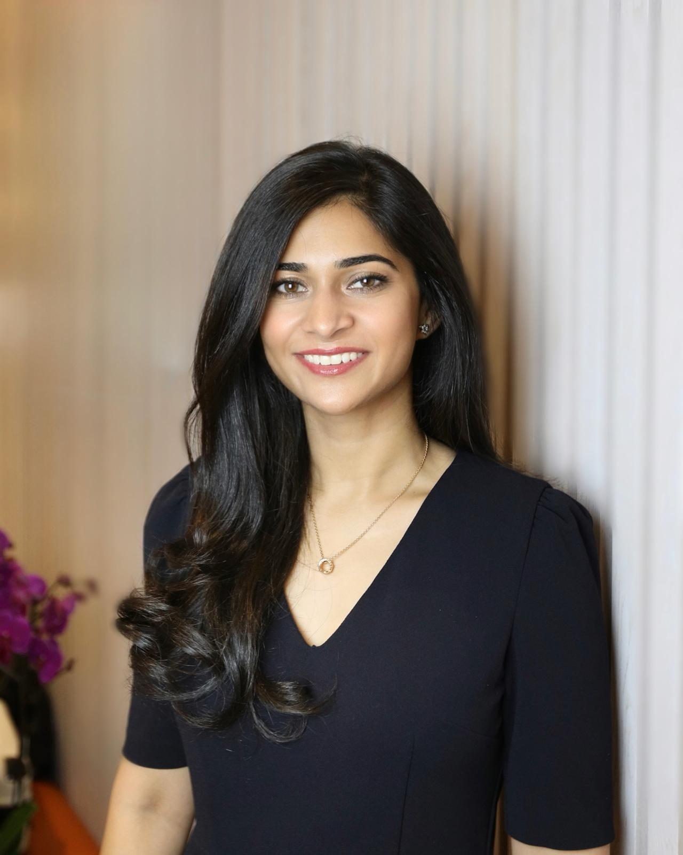
Building inclusive, expert‑led spaces that support physical and emotional postpartum recovery.

- Contacts:
Email: pri@rivawelness.co.uk
Instagram
Website
Linkedin (Riva)
LinkedIn (Personal)

Samantha Watson
Osteopath & Health Coach – Discovering Wellness
- Contacts:
Email: sam@discoveringwellness.co.uk
Website: discoveringwellness.co.uk
Instagram: @samtheosteocoach
Guides clients to heal their relationship with food and build balanced, sustainable lifestyles.

Shell (Michelle Rees)
Personalised Nutrition & Fitness Coach – Be Well With Shell 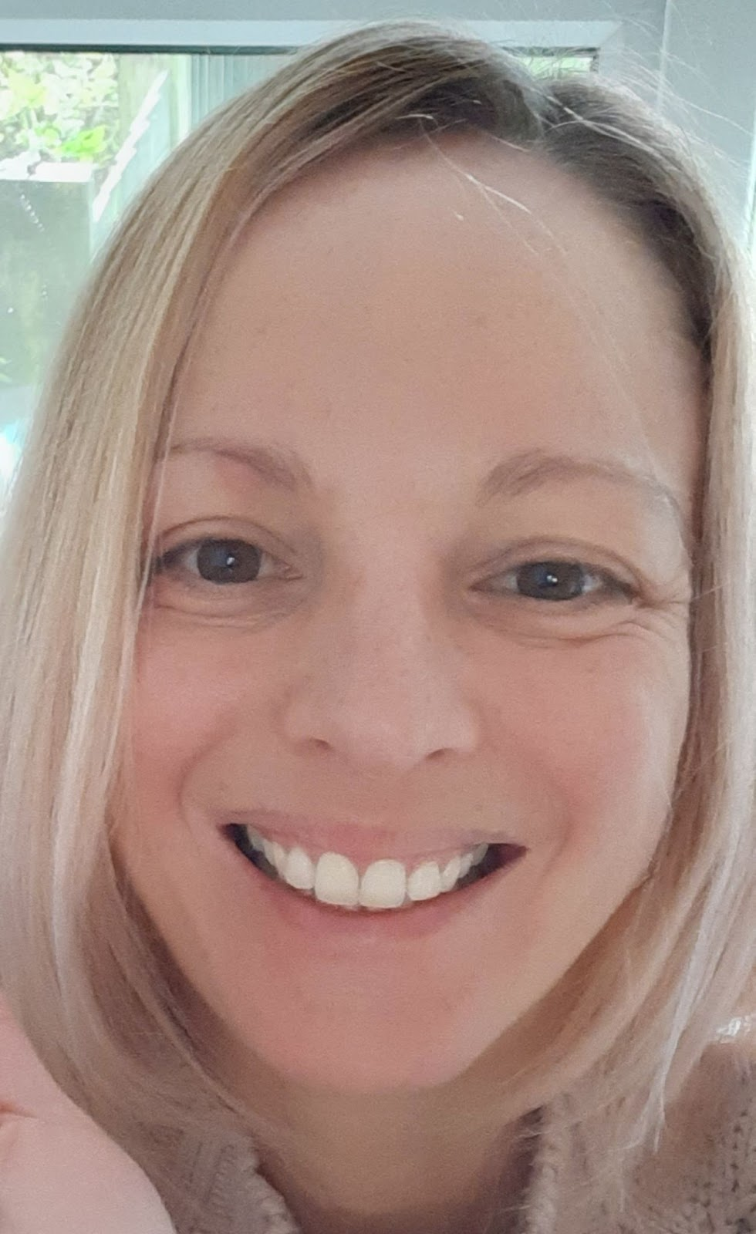
Test‑based nutrition and sustainable lifestyle coaching in East Sussex and online.
- Contacts:
Email: shell@bewellwithshell.com
Website: bewellwithshell.com
LinkedIn: linkedin.com/in/michelle-rees-a6558519a

Stephanie Camilleri
Founder – The ADHD Advocate
- Contacts:
Email: stephanie@theadhdadvocate.com
Website: theadhdadvocate.com
Advocates, educates and supports individuals with ADHD through coaching and consultancy.

Sunila Prasad MBBS BSc MRCPCH Lic.Ac
Medical Doctor & Acupuncturist – SP Acupuncture 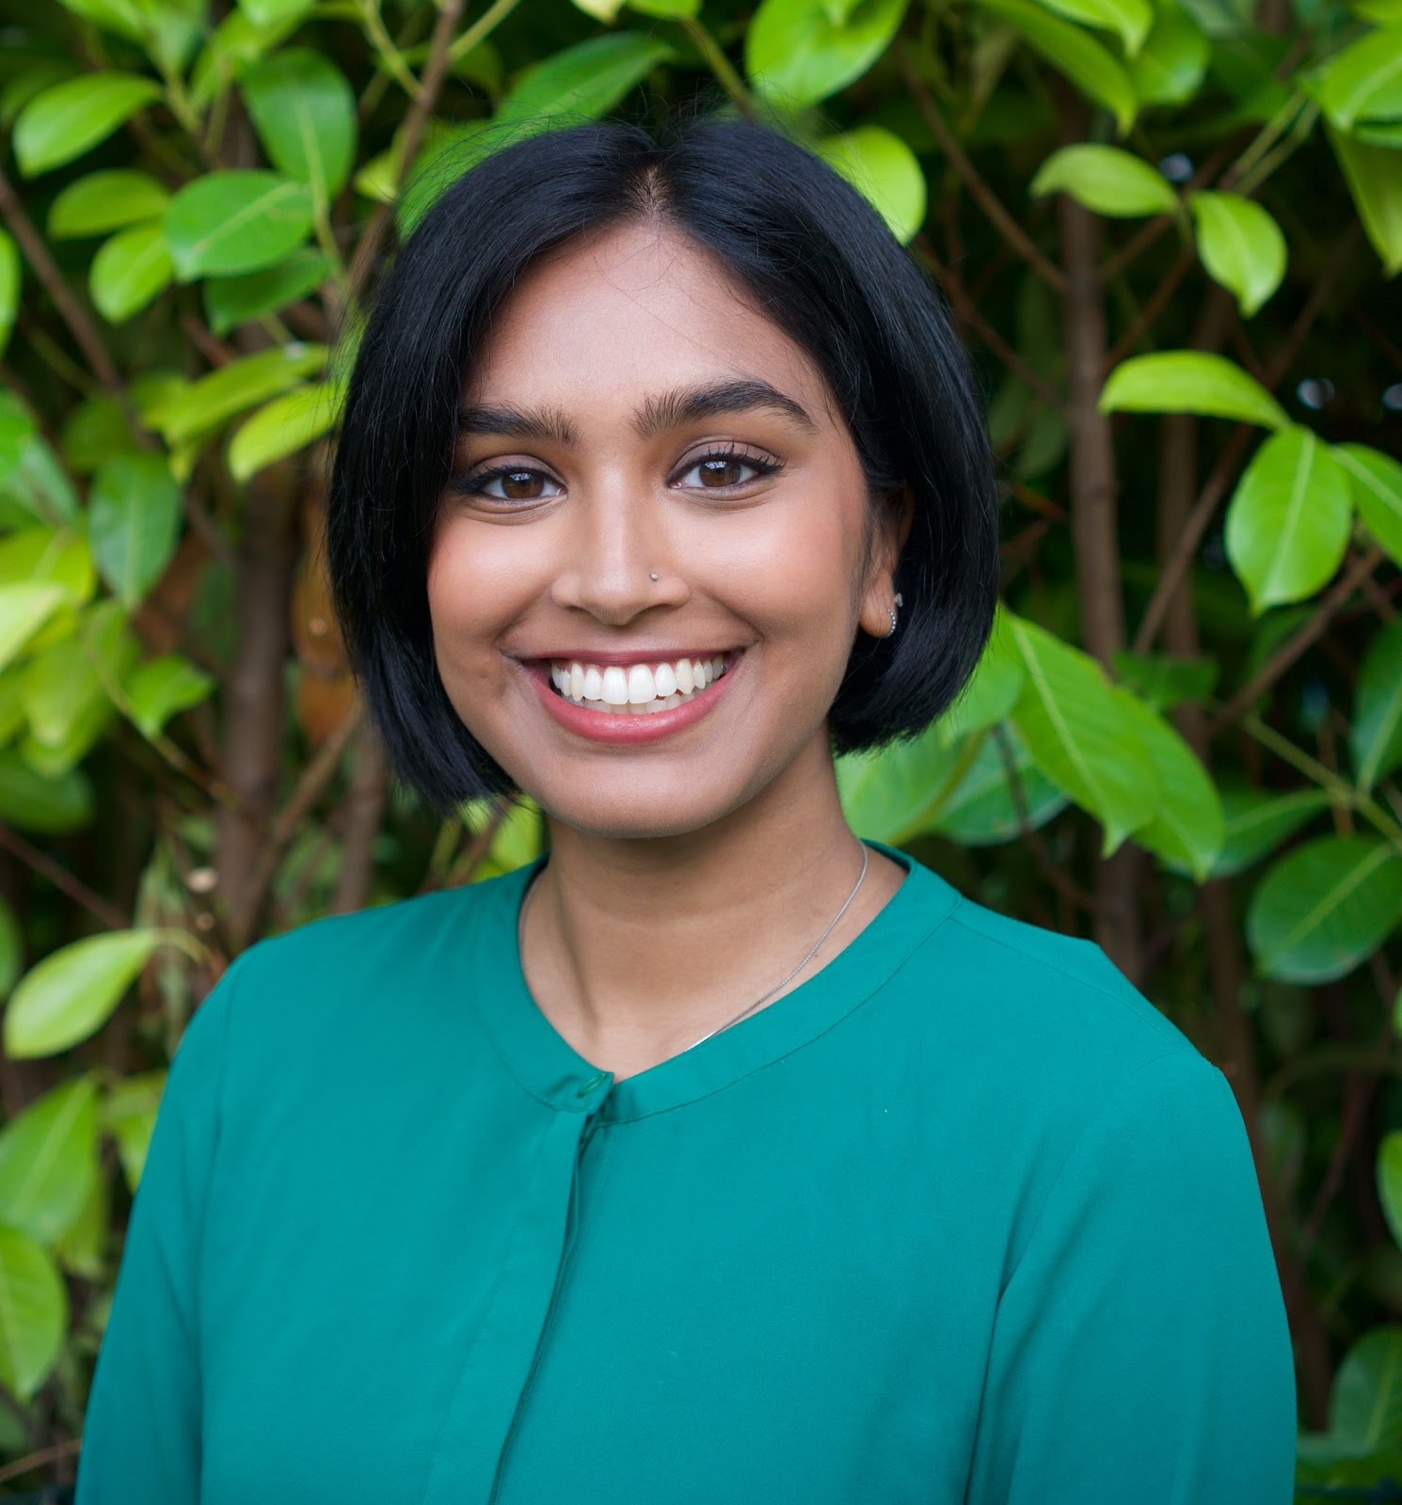
Combines Western medicine and traditional Chinese techniques to deliver holistic women’s health care.

- Contacts:
Email: sunilap.acu@gmail.com
Instagram: @sp.acupuncture
Mobile: 07424 477 319

Susannah Dale
Founder – The Maternity Pledge & The Matrescence Club 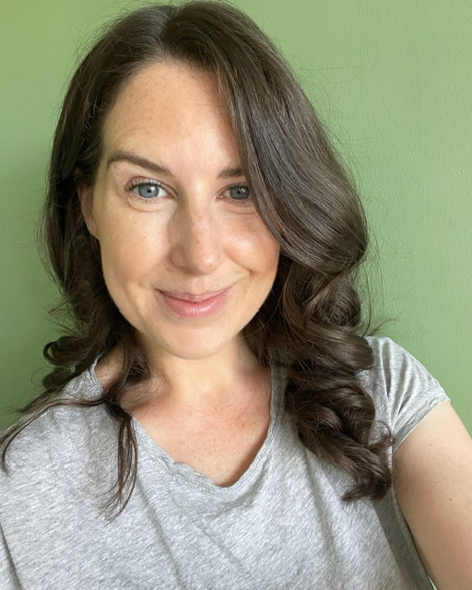
Creates antenatal and workplace resources on matrescence; runs social‑impact training for organisations to better support new parents.

- Contacts:
Email: susannah@maternitypledge.com
Website: maternitypledge.com
Instagram: @matrescence_club
Phone: 07535 007 276

Wizz Selvey

Co-Founder, Valerie
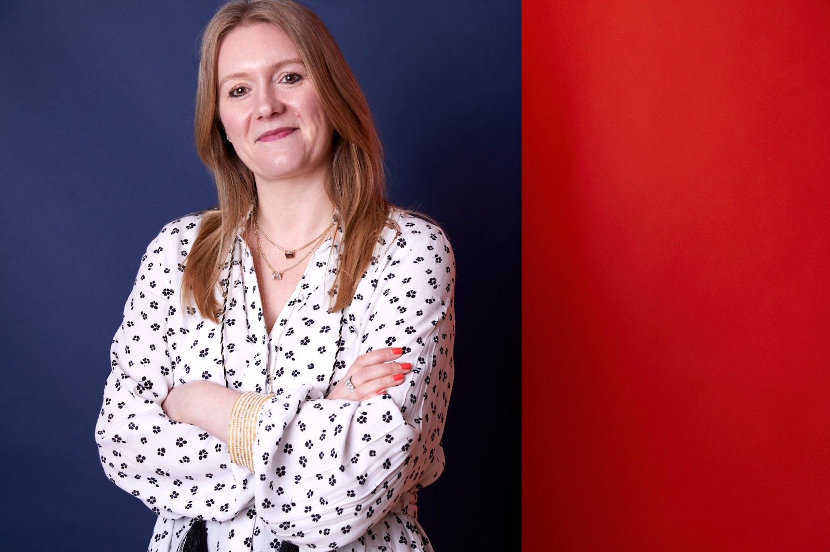
A former beauty-brand trendspotter who’s now on a mission to make perimenopause feel normal, Wizz co-created Valerie’s easy-to-take liquid supplements so women can keep their spark without the fuss.

- Contacts:
wizz@wearevalerie.com
https://wearevalerie.com/
https://instagram.com/weare.valerie
https://tiktok.com/@weare.valerie
https://www.facebook.com/people/Valerie/61553752936091/
https://www.linkedin.com/in/wizz-selvey-14915552/
https://www.instagram.com/wizzbangwizzy/

